**Ticketing System Design**

**What is Ticketing System:**

italic and underline

Users submit requests or report issues through various channels such as email, web forms, phone calls, or chatbots. These requests are typically categorized based on their nature, such as technical support, customer service, or IT assistance. The ticket may be assigned to a specific support agent or team responsible for addressing requests of that type.

Ticketing systems often include reporting and analytics features that allow organizations to track key metrics such as response times, resolution rates, and customer satisfaction scores. This data helps identify trends, areas for improvement, and overall performance of the support team.

**Stepts Involved:**

STEP1:

Receiving Customer Requests:

Receiving Customer Requests is the initial step in the ticketing system workflow where users or customers submit their inquiries, issues, or requests for assistance. This step is crucial as it marks the beginning of the support process and sets the stage for addressing the customer's needs effectively.

Customers may submit their requests through various channels such as email, phone calls, web forms, chatbots, or self-service portals.

Upon receiving the request, the ticketing system automatically generates a new ticket. This ticket serves as a centralized record of the customer's request and contains all the relevant information needed for support agents to address the issue.

Once the ticket is created, the customer may receive an acknowledgment or confirmation to let them know that their request has been received. This acknowledgment typically includes a unique ticket number or reference ID that the customer can use to track the progress of their request.

STEP2:

Creating a Support Ticket:

Upon receiving the user's request, the ticketing system automatically generates a new support ticket. This ticket serves as a centralized record of the user's issue or request and contains all the pertinent information captured during the submission process.

The ticket may be classified into different categories or assigned a priority level based on predefined criteria or rules. Classification helps in organizing and routing tickets to the appropriate support team or department, while prioritization ensures that urgent issues receive prompt attention.

The ticketing system may automatically assign the newly created ticket to a specific support agent or team based on factors such as workload, skillset, or specialization. Alternatively, a dispatcher or supervisor may manually assign the ticket to an available support resource.

STEP3:

Tracking & Analyzing the Tickets:

Ticketing systems allow support agents and administrators to track the status of each ticket throughout its lifecycle. Common status categories include "Open," "In Progress," "On Hold," and "Resolved."

Support teams monitor the progress of individual tickets to ensure that they are being addressed in a timely and efficient manner. This involves tracking key metrics such as response times, resolution times, and any actions taken to resolve the issue.

In cases where a ticket cannot be resolved by the initial support agent or team, it may be escalated to a higher level of support or management for further attention. Ticketing systems track escalations to ensure that unresolved issues are promptly addressed by the appropriate resources.

Based on the insights gained from tracking and analyzing tickets, organizations can implement changes to improve their support processes continually. This may involve refining workflows, providing additional training to support agents, updating documentation and knowledge bases, or implementing new tools or technologies to enhance efficiency and customer satisfaction.

STEP4:

Close the Feedback Loop:

Once a support ticket has been resolved and marked as closed, the ticketing system may automatically trigger a feedback request to the user who submitted the ticket. This request could be in the form of an email, a survey, or a follow-up message within the ticketing system itself.

Customers are asked to provide feedback on their support experience, typically through a rating system or open-ended questions. They may be asked to rate the responsiveness of the support team, the helpfulness of the solutions provided, and their overall satisfaction with the support experience.

Based on the analysis of feedback, support teams take action to address any issues identified and improve the overall support experience. This may involve providing additional training to support agents, updating documentation or knowledge bases, implementing process improvements, or making changes to products or services based on customer suggestions.

STEP 5

Set Email Notifications:

Users can choose which events or actions they want to receive notifications for. Common events include when a new ticket is created, when a ticket is assigned to them, when there are updates or comments on their tickets, when a ticket is resolved, or when there are any changes to the status or priority of their tickets.

The user can choose the format of the notifications (plain text, HTML), and the email address(es) where they want to receive the notifications.

Users typically have the option to opt out of receiving email notifications altogether if they prefer not to receive them. This ensures that users have control over their notification preferences and can manage their inbox effectively.

Sample Interfaces:

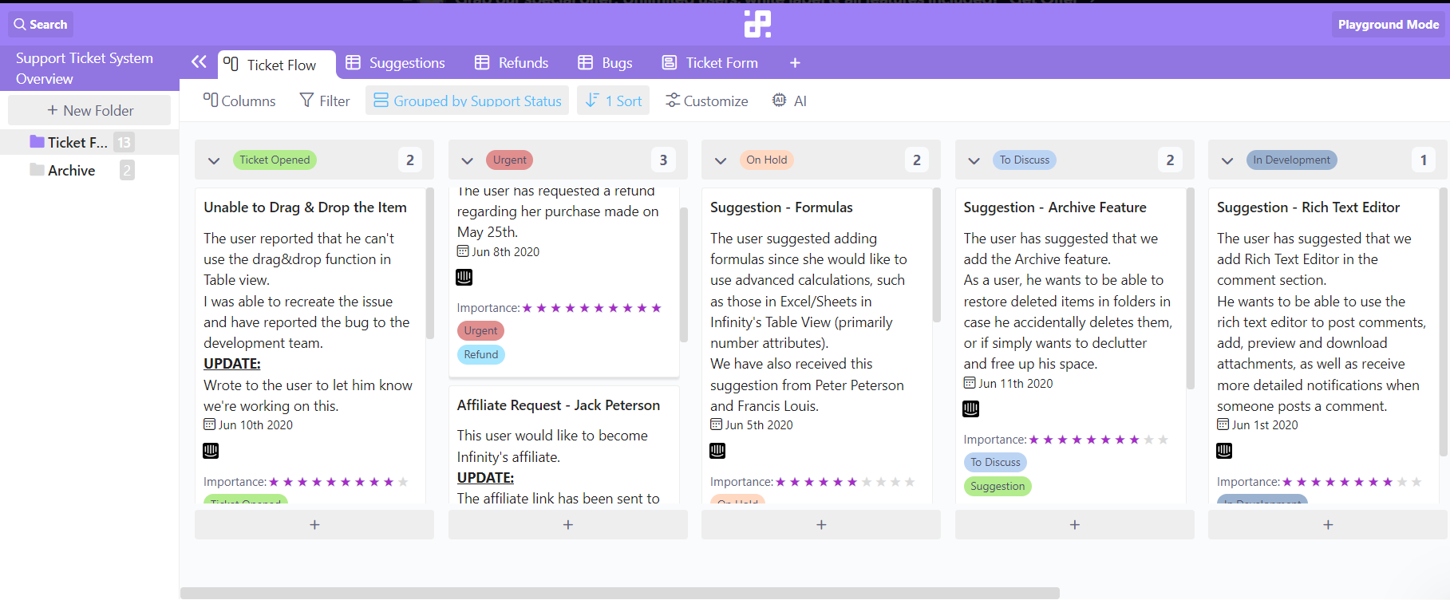

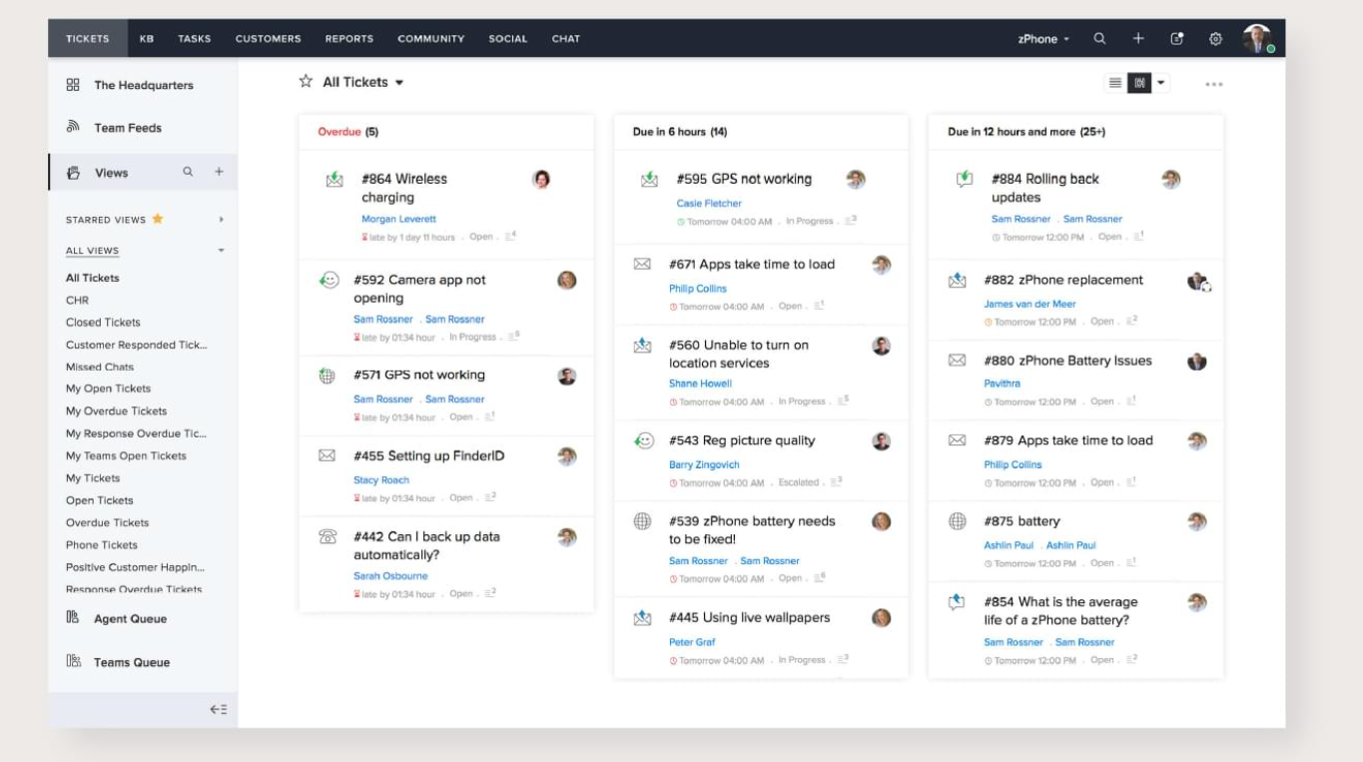

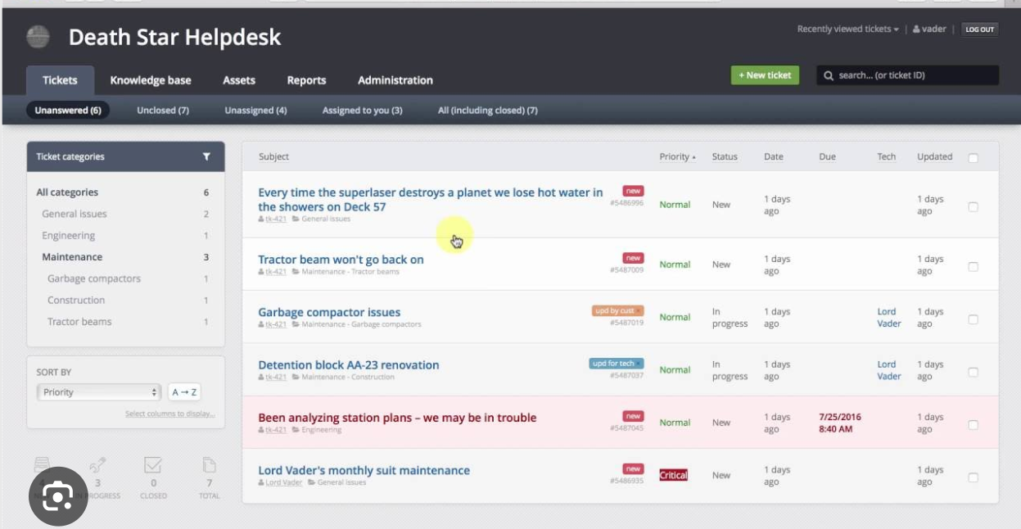

The file is being modified using docx module.  
This module can be used to read,write doc files